# The Midpoint application

## TOOL TO MEET IN THE MIDDLE

# Index

*Preface* 3

Chapter 1: Introduction 4

Overview 4

Input tab 4

Output tab 6

Chapter 2: Using 7

# Preface

This manual is the user manual for the Midpoint application. It describes how the user should use the application for optimum results.

Version: 1.1 Beta

Author: Marc van Dorenmalen

|  |  |
| --- | --- |
| 10-1-2020 | Initial version |
| 15-1-2020 | Manual changed because of: added features and refactoring asynchronized methods.  Added features:   * Make addresses unique * Show status message * Make is possible to change radius and filter without having to reset. * Reset if bad addresses are given. |

# Chapter 1: Introduction

This chapter provides an overview of the Midpoint application screen. Figure 1 shows the start screen.

## Overview

In this section we give an overview of the Midpoint application screen.

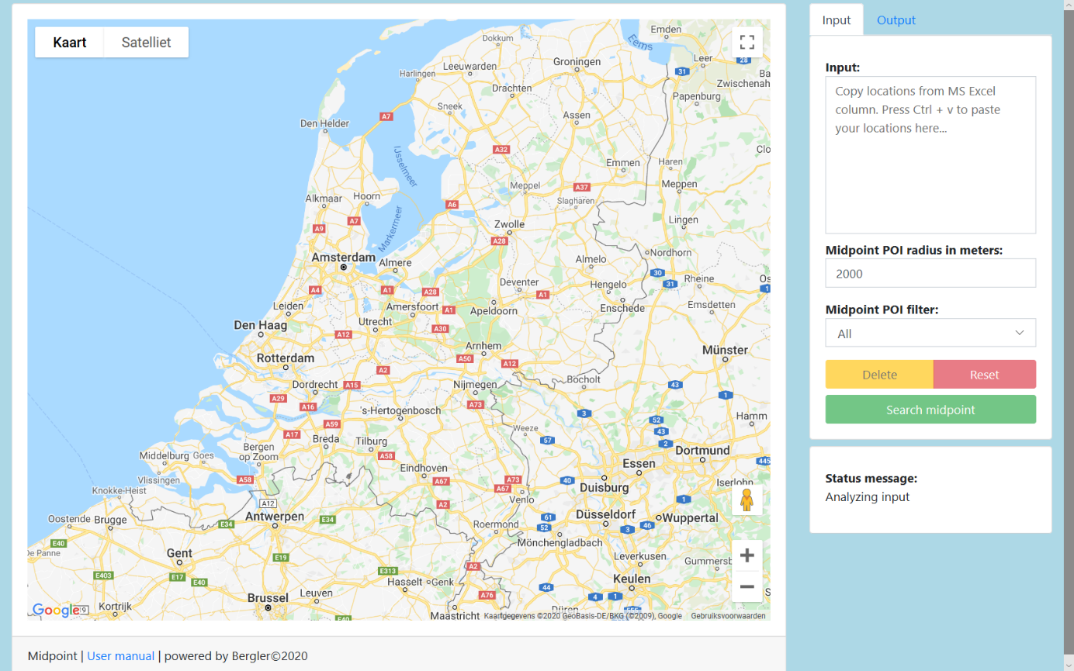

Figure 1: the default screen when opening the Midpoint application.

On the left side of the screen a Google maps map can be seen and this will be opened with an overview of the Netherlands.

The control panel can be seen on the right side of the screen. Het bedieningspaneel bevat een "Input" en een "Output" tabblad.

The screen also contains an area to show status messages.

### Input tab

This section describes the Input tab. Figure 2 shows the Input tab.

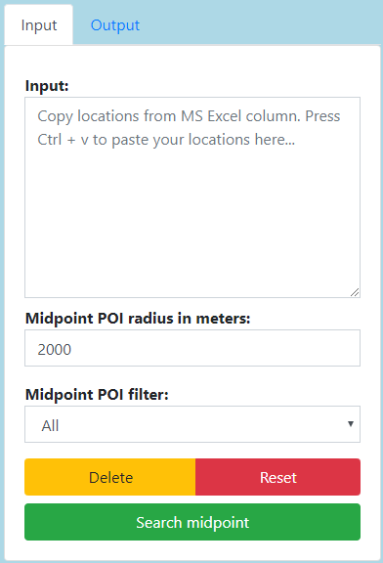

Figure 2: the Input tab.

Input

You must enter the addresses in this section. The easiest way is to copy and paste a column of addresses from Microsoft Excel.

Midpoint POI radius in meters

In this field you must specify the radius to search for point of interest from the midpoint that is calculated.

Midpoint POI filter

Select a filter to see only point of interest places that you have selected.

Delete

You can delete addresses after entering addresses. Any existing plots are deleted. Output fields are also deleted. You must activate search again if you have not yet done this.

Reset

Return to the initial screen where all input and output are deleted.

### Output tab

This section describes the Output tab. Figure 3 shows the Output tab.

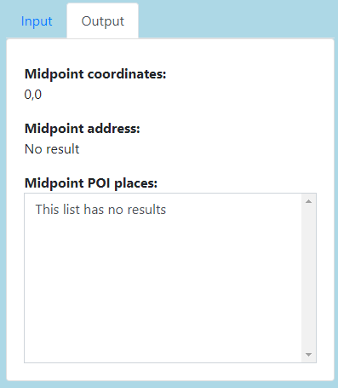

Figure 3: the Output tab.

Midpoint coordinates

If the midpoint is calculated, the coordinates are shown here.

Midpoint address

If the midpoint is calculated, the address is shown here.

Midpoint POI places

If the midpoint is calculated, the POI places are listed here.

# Chapter 2: Using

This chapter provides an description for the steps that needs to be taken if you want to use the Midpoint application, based on example data.

Step 1 Addresses input

This section show how you can collect input data for the Input field inside the Input tab. Figure 4 shows a selected column with address data. Select your data and press the Ctrl + c key on your keyboard.

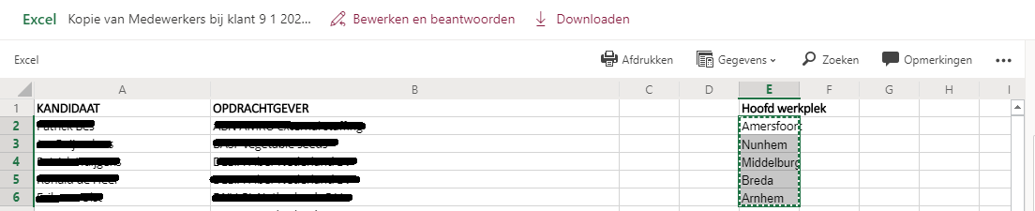

Figure 4: Microsoft Excel sheet with example data.

Step 2 Paste the copied address in the Input field. Please see figure 5.

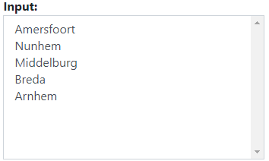

Figure 5: the input field generates a selection list from the data, after you pressed the Ctrl + v keys on your keyboard.

Step 3 Radius

Check the radius to find point of interest places within the given radius from the calculated midpoint.

Step 4 Filter

Check the filter setting to show only the point of interest places from your selection.

Step 5 Delete

Check if the input addresses are correct. If you want to remove an address, select the address from the Input field and press the Delete button.

Step 6 Search midpoint

Press the “Search midpoint” button to start the midpoint calculation. After the calculation, the map zooms in to the midpoint. The map will show you the following plots:

http://maps.google.com/mapfiles/ms/icons/blue-dot.pngIndicates a POI place. You can click the blue plots to see the address information, that is also displayed in the Midpoint POI places list from the “Output” tab.

http://maps.google.com/mapfiles/ms/icons/red-dot.pngIndicates an input address.

http://maps.google.com/mapfiles/ms/icons/green-dot.pngIndicates the midpoint.

**Notice:** it is possible that no other plots are visible, if there are no POI places or input addresses nearby. To see the plots, you can zoom out the map, by moving the mouse cursor over the map and use scroll the mouse wheel or by using the “-” button inside the map.

Step 7 Reset

If you want to start over, press the Reset button.

Step 8 Output

Click the “Output” tab to see the other midpoint results. Figure 6: shows the result after executing the Search midpoint function.

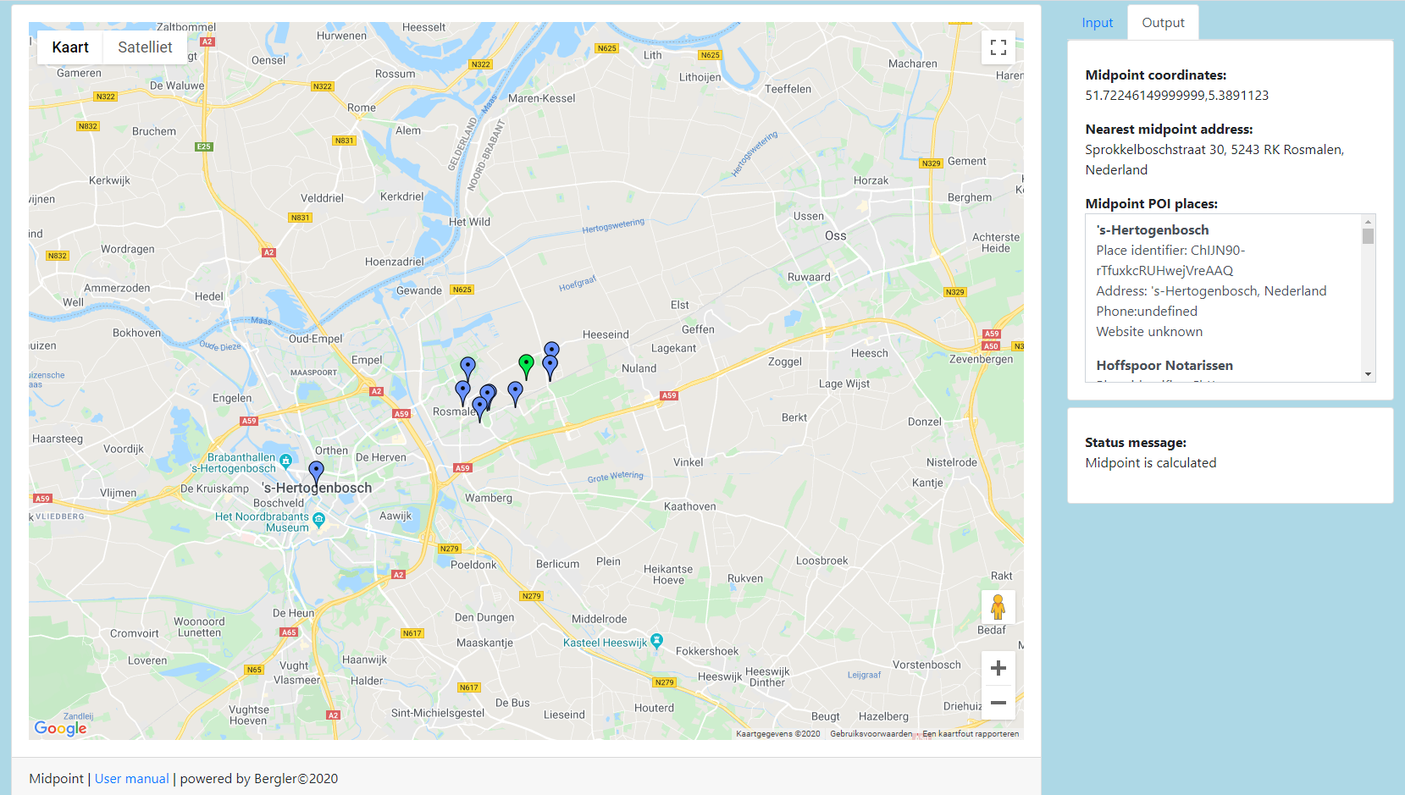

Figure 6: the result of the Search midpoint function.

The output tab contains the following information:

The midpoint coordinates.

The midpoint address.

A list of the POI places nearby.

Step 9 Start over

To start over, open the “Input” tab, press the Reset button and repeat the steps starting with step 1.